|  |
| --- |
| Martin Rule, Lane Cotgrove, James Bayliss |
| Motion Project |
| Avateering client user guide |

|  |
| --- |
| Martin Rule  9/19/2012 |

Table of Contents

1. Introduction 2

2. Requirements 2

3. Set up 3

3.1 Kinect software development kit 3

4. Installation 3

5. First time use 4

## 1. Introduction

The avateering client developed for Sensing places is used to display movement data gathered from a local or remote server. For a technical specification of how this works please refer to the development documentation.

This guide will provide information on the set up and operation of this program.

## 2. Requirements

This application was developed on x84 and x64 based Windows 7 systems. Some issues may be experienced with other windows systems (Windows XP etc). Currently there is no support for Linux or IOS based systems.

Memory: 1GB+  
Processor:2.2Ghz Dual Core+  
Operating system: X84 or X64 Windows  
Video: Modern graphics card with 256mb+ memory  
Network: High speed broadband connection

## 3. Set up

Before installation

There are three things you will need before the program can operate successfully. If you already have one or more of these requirements please check they are updated to the newest version.

## 3.1 Kinect software development kit

This is an essential part needed for the operation of this system. It contains many components used through the Avateering client system. This can be downloaded from the official Microsoft Kinect website. This includes the develop toolkit which has the original version of this client developed by Microsoft.

## 4. Installation

The application is a standalone executable that requires no specific installation. You may however need administrator rights for this system to work correctly.

## 5. First time use

When you start the Avateering client it will ask you a couple of questions about your new session.

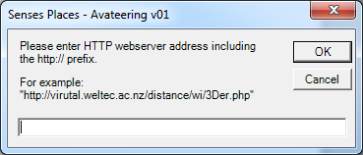

First it requires a valid server address. This can be either a local or remote server from which you wish to retrieve and use movement data.

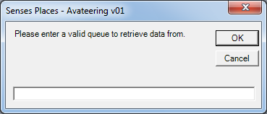

Then the program will ask which queue you wish to retrieve movement data from. This program has been developed with Sensing Places servers which have multiple queues used for the storing and pulling of information.

If, by any chance you have made a mistake during the address and queue set up of the program, the program will reattempt to ask you the same questions three times. If you are unable to enter the correct information during each of the three times, the program will automatically exit.

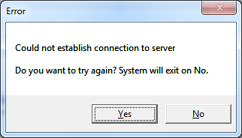

If there is an issue with the details provided or the server you are trying to connect to you will be presented with this error and prompted to try again. Please refer to the development documentation for more information on what is being expected and how it works.

Finally you should be presented with this user interface

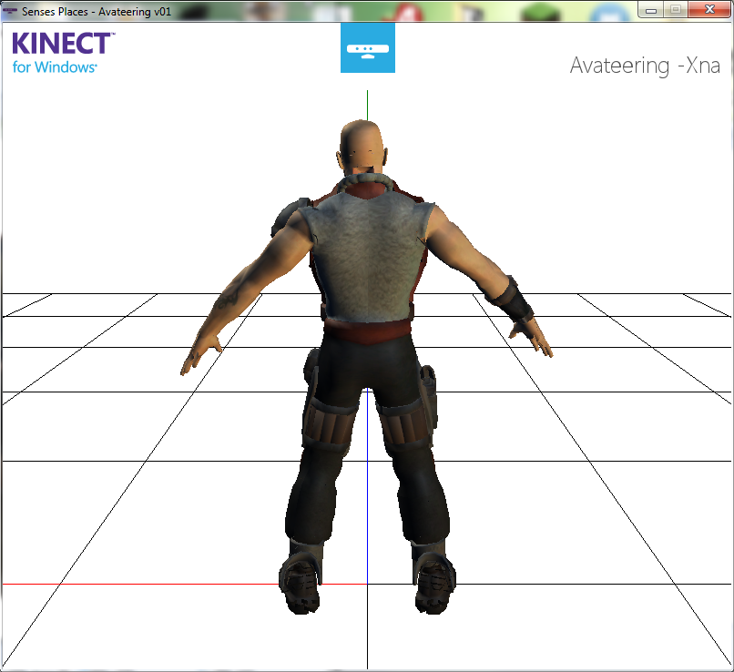

Assuming everything worked correctly the avateering client will now be automatically pulling movement data from your server and displaying it using the 3D avatar.